

WebSphere MQ
Setting up SSL for Distributed MQ

SOA ITS MQ Administration

1 Intro 5
1.1 Why sign a certificate? 5
1.2 When to use an external CA 6
2 Issuing a certificate to a queue manager 7
2.1 Set the pathname for the queue manager’s key repository file 7
2.2 Create the queue manager’s key repository 7
2.3 Create a certificate request 8
2.4 Transfer the request 10
2.4.1 How to transfer the certificate request file to the CA 11
2.5 Obtain the CA-signed certificate 11
2.5.1 How to transfer the certificates back from the CA 11
2.5.2 Viewing the certificate files 12
2.6 “Add” the CA certificate 12
2.7 “Receive” the signed certificate 14
3 The Internal Certificate Authority 16
3.1 Creating a certification authority (CA) 16
3.1.1 Create a key repository for the CA 16
3.1.2 Create your self-signed CA certificate 17
3.1.3 Extract the CA certificate 18
3.2 Signing Certificate Requests 20
3.2.1 Receive the CSR 20
3.2.2 Sign the queue manager’s certificate 20
3.2.3 Transfer the CA-signed certificate 21
4 Using self-signed certificates for mutual authentication on UNIX® systems or Windows 22
4.1 Create KDB 22
4.2 Create Self signed Cert 22
4.3 Extract public part of cert 22
4.4 Transfer Certificates 22
4.5 Add the public part of a self-signed certificate) into a key repository, on UNIX systems or Windows 22
4.6 Setup MQ 23
5 Back up your SSL certificate 24
5.1 Export Key to a PKCS12 24
5.1.1 To export a personal certificate using gsk7ikm GUI: 24
5.1.2 To export a personal certificate using GSK7Cmd 24
5.2 Import Key from a PKCS12 25
5.2.1 To import a personal certificate using gsk7ikm GUI: 25
5.2.2 To import a personal certificate using GSK7Cmd 26
6 OTHER 28
6.1 PROBLEM: Duplicate certificate serial numbers 28
6.2 Renewing WebSphere MQ SSL Certificates 28
6.2.1 Problem(Abstract) 28
6.2.2 Resolving the problem 28
6.2.3 On UNIX and Windows 29
6.3 Using Exceed and gsk7ikm on UNIX 30
6.4 Commands 35
6.4.1 Delete Certs 35
6.4.2 List Certs 35
6.4.3 List Expiration 35

Revisions:

Version | Dates | Author | Description of changes
1.0 | Dec. 28, 2011 | Charles Behnken | Initial Document
1.1 | Sept 25, 2011 | Charles Behnken | Removed Expiry from KDB as it was causing failures we could not track,

Intro
SSL is used to encrypt data on MQ Channels and SSL requires Digital Certificates to accomplish this. One can either used Self-Signed Certificates, but this requires the public key of all Queue Managers to be distributed and installed in all partner Queue Managers key database. As the network gets larger this becomes burdensome. The other option is to purchase certificates from third party CA’s like VeriSign or Thawte. Their Root Certificate is normally installed in the key database as part of the build. The acquisition of certificates from CA’s involves a cost and can get expensive. This solution is normally required for communicating with external Queue Managers and should be reserved for that problem.

A more effective solution is to be your own Certificate Authority and use these Certificates for internal Queue Managers and MQ clients. With this solution only the internal Root CA Certificate needs to be installed, along with the Queue Manager Certificate, in each Queue Manager’s key database.

Following the steps in this document, you will use the command-line utilities supplied with WebSphere MQ to:
- Create your own CA.
- Issue a signed certificate for a queue manager
Additional documentation will discuss:
- Issue a signed certificate for a C or C++ application
- Issue a signed certificate for a Java application
- Run a C application, to prove that it works
- Run a Java application, to prove that it works

Why signed certificates?
A certificate signed by your CA can be used to identify a single entity in your infrastructure, such as a queue manager, a client program, or a user. By signing a certificate, the CA is certifying that the certificate can be trusted. If you are acting as a CA, you must satisfy yourself somehow that the person (or workgroup, etc.) presenting you with a certificate request is indeed who they say they are. How you satisfy yourself of this is a subject beyond the scope of this document.

CA Trusted Root
Development
Queue Manager A Certificate
(signed by CA Trusted Root)
Queue Manager B Certificate
(signed by CA Trusted Root)
Queue Manager C Certificate
(signed by CA Trusted Root)

When to use an external CA
It isn’t always necessary to manage your own CA within your enterprise. Another option is to purchase signed certificates from a trusted vendor. Some advantages of taking this approach include:
-  The vendor manages expiry and renewal of certificates, to reduce risk associated with theft of certificates
-  The vendor public certificate(s) are very likely to be installed on all systems in your enterprise. This means you might save any costs associated with transferring your CA’s public certificate to all systems in your enterprise – for example when a client system is re-installed after a major hardware or software failure.

Issuing a certificate to a queue manager
Each queue manager in your infrastructure should have its own certificate, with an appropriate distinguished name (DN). The DN should be unique within the WebSphere MQ network.

Set the pathname for the queue manager’s key repository file
One can set the location of the Queue Manager’s key repository via the Alter QMGR SSLKEYR(xxx) command. We will use the default location of …./qmgrs/Qmgrname/ssl/key

Notes:
-  Each queue manager requires a key repository in order to store its certificate, and the associated private key.
-  The default location in which a queue manager looks for its key repository is (assuming a default installation directory) /var/mqm/qmgrs/myqmgr/ssl or C:\Program Files\IBM\WebSphere MQ\Qmgrs\myqmgr\ssl or
-  The default filename a queue manager looks for when locating its key repository is key.kdb.
-  The queue manager’s SSLKEYR attribute contains the full path to the key repository, followed by the name of the key repository, up to, but not including, the .kdb.

Create the queue manager’s key repository
Change directory to the location where the key repository file is to be created, and issue the following command to create a key database for the queue manager:

Windows:
C:\...> cd C:\Program Files\IBM\WebSphere MQ\Qmgrs\myqmgr\ssl
C:\...> runmqckm -keydb -create -db myqmgr.kdb -type cms –stash –pw password -type cms–stash

UNIX:
$cd /var/mqm/qmgrs/myqmgr/ssl
$gsk7capicmd -keydb -create -db myqmgr.kdb -pw password
-type cms -stash

Where myqmgr.kdb key.kdb
password Devel: PaTaGonia2010
Prod: YoSeMite1842

Examples:

- UNIX - from /var/mqm/qmgrs/QMGRNAME/ssl directory
gsk7capicmd -keydb -create -db key.kdb -pw PaTaGonia2010 -type cms -stash

gsk7capicmd -keydb -create -db key.kdb -pw YoSeMite1842 -type cms -stash

- Windows - from C:\Program Files\IBM\Websphere MQ\qmgrs\QMGRNAME\ssl directory
runmqckm -keydb -create -db key.kdb -pw PaTaGonia2010 -type cms –stash

runmqckm -keydb -create -db key.kdb -pw YoSeMite1842 -type cms –stash

Notes:
-  If you do not include the –pw specification, you will be prompted to create a password. Wait for the prompt, and then type the password you want to use for the CA’s key repository.
- It is important that this password is kept safe, as it protects the private key of the signed certificate. This password is required for later commands in this section.
- The -stash option is important, as it causes a ‘stash file’ to be created. This file is called myqmgr.sth . It allows the queue manager to open the key repository without requesting a password from the user.
- If you want the password on the KeyDB to expire add -expire days to the command.

Deployment note:
-  Access to the …/ssl directory should be granted only to the ‘mqm’ group, to protect the integrity of your security policy.
- IMPORTANT: Set the permissions appropriately for your environment. If necessary, to help you implement an appropriate security policy, consult with the team that decides security policy in your organization.

Create a certificate request
Generate a certificate request file for the queue manager, along with a private key. Later on, this certificate request will be signed by our CA.

Windows:
C:\...> runmqckm -certreq -create -db myqmgr.kdb -pw password
–label label -dn "distinguished_name" -size key_size
-file request_file

UNIX
$gsk7capicmd -certreq -create -db myqmgr.kdb -pw password -label label
-dn "distinguished_name" -size key_size -file request_file

Where myqmgr.kdb key.kdb
password Dev: PaTaGonia2010
Prod: YoSeMite1842
label ibmwebspheremqqmgrname
key_size 1024
distinguished_name
"CN=qmgrname.host,O=BTMU,OU=ITS.SOA.MQ, L=NewJersey,C=US"
request_file qmgrname.req
qmgrname Queue Manager associated with this key
host machine hosting the queue manager

Examples
- From /var/mqm/qmgrs/MQSISIT1/ssl
$gsk7capicmd -certreq -create -db key.kdb -pw PaTaGonia2010 -label ibmwebspheremqmqsisit1 -dn "CN=MQSISIT1.sfmqsidevl2.btmna.com,OU=SOA.ITS.MQA,O=BTMU,L=New Jersey,C=US" -size 1024 -file mqsisit1.req

gsk7capicmd -certreq -create -db key.kdb -pw PaTaGonia2010 -label ibmwebspheremqextgws01 -dn "CN=EXTGWS01.njmqgwdevl.btmna.com,OU=SOA.ITS.MQA,O=BTMU,L=New Jersey,C=US" -size 1024 -file extgws01.req

- From /var/mqm/qmgrs/MQSIPROD/ssl
gsk7capicmd -certreq -create -db key.kdb -pw YoSeMite1842 -label ibmwebspheremqmqsiprod -dn "CN=MQSIPROD.mqsiprod.btmna.com,OU=SOA.ITS.MQA,O=BTMU,L=New Jersey,C=US" -size 1024 -file mqsiprod.req

gsk7capicmd -certreq -create -db key.kdb -label ibmwebspheremqextgws02 -dn "CN=48777346,OU=SOA.ITS.MQA,O=BTMU,L=New Jersey,C=US " -size 1024 -file extgws01.req

- From /var/mqm/qmgrs directory (in this example multiple queue managers are done from one directory by specifying path information):
gsk7capicmd -certreq -create -db MQSIUAT2/ssl/key.kdb -pw PaTaGonia2010 -label ibmwebspheremqmqsiuat2 -dn "CN=MQSIUAT2.sfmqsidevl.btmna.com,OU=SOA.ITS.MQA,O=BTMU,L=New Jersey,C=US" -size 1024 -file MQSIUAT2/ssl/mqsiuat2.req
gsk7capicmd -certreq -create -db MQSIUAT3/ssl/key.kdb -pw PaTaGonia2010 -label ibmwebspheremqmqsiuat3 -dn

"CN=MQSIUAT3.sfmqsidevl.btmna.com,OU=SOA.ITS.MQA,O=BTMU,L=New Jersey,C=US" -size 1024 -file MQSIUAT3/ssl/mqsiuat3.req

- From C:\Program Files\IBM\WebSphere MQ\Qmgrs\idtsit2\ssl directory:
runmqckm -certreq -create -db key.kdb -pw PaTaGonia2010 -label ibmwebspheremqidtuat2 -dn "CN=IDTUAT2.usny01dev023.btmna.com,OU=SOA.ITS.MQA,O=BTMU,L=New Jersey,C=US" -size 1024 -file idtuat2.req

runmqckm -certreq -create -db key.kdb -pw PaTaGonia2010 -label ibmwebspheremqcbmq1 -dn "CN=CBMQ1.Charles.btmna.com,OU=SOA.ITS.MQA,O=BTMU,L=New Jersey,C=US" -size 1024 -file cbmq1.req

- From C:\Program Files\IBM\WebSphere MQ\Qmgrs\QM!DHBN01\ssl directory (Example of QM name with a period):
runmqckm -certreq -create -db key.kdb -pw PaTaGonia2010 -label ibmwebspheremqqm.dhbn01 -dn "CN=QM.DHBN01.usny01app021.btmna.com,OU=SOA.ITS.MQA,O=BTMU,L=New Jersey,C=US" -size 1024 -file qm.dhbn01.req

Notes:
- If you do not include the –pw specification, you will be prompted for a password. Supply the password for the queue manager key repository. This was chosen and first used in Step 3.2.
- The distinguished name (DN), as specified in the -dn parameter, should be tailored to your organization and uniquely identify the queue manager within the infrastructure
- The label, as specified with -label parameter, must be of the form ibmwebspheremqmyqmgr , all in lower case. This is important, as otherwise the queue manager will fail to find the certificate.
- If the queue manager name contains a period, the label must also contain the period. It is not munged to an exclamation point, and it is still all lower case. e.g. ibmwebspheremqqm.dhbn01
- The following commands allow you to list the Certificate requests in the key database, or delete a certificate request in the key database (so the request can be corrected and reentered):
gsk7capicmd -certreq -list -db key.kdb -pw password
gsk7capicmd -certreq -delete -db key.kdb -pw password -label ibmwebspheremqqmgrname

Transfer the request

How to transfer the certificate request file to the CA
The certificate request file contains Base64 encoded ASCII data. If you plan to use FTP to transfer this file between machines, then you should use the “ascii” command in the FTP client program before the “put” or “get” commands to ensure the file is transferred in the correct format.

Optionally as the certificate requests are text files looking like the following, they can be emailed as either attachments, or in the body of the email.

-----BEGIN NEW CERTIFICATE REQUEST-----
MIIBZzCB0QIBADAoMSYwJAYDVQQDDB1UMlFNR1Igb3U9QlRNVSBvPVNPQS1JVFMg
Yz1VUzCBnzANBgkqhkiG9w0BAQEFAAOBjQAwgYkCgYEA69dsGb7yP7xnh7MHmidD
h2gu3gYO46eVreoIQuv4nUfiuwM30DXfoOHsvI03QwoZ+xFqssPmdjDJhVsaQgSp
oLaYxln4x1ck5MG2nzxaBAmjkzxwahHydPVvsKoBcteOXKPMMuZo/T935pcWmBF3
Um3Ut09jckBYD8hQPwwxiVECAwEAAaAAMA0GCSqGSIb3DQEBBQUAA4GBAGsmiIpB
7NbfrJZuC8c8ERg9t9Df7xcaHK6HPw2VbCekL+8s7vS9CSc4HQmxU1Kui1WBNkBR
LEUxFflUvBxmVyX1oBI2B8n2y1oO7+FvGLhoWAPNUmCpuJeNXReHk69AOpcwf0fI
yzDorNnqtKFhjTvsNEU08EPfPBp11NBNS07n
-----END NEW CERTIFICATE REQUEST-----

Obtain the CA-signed certificate

How to transfer the certificates back from the CA
Two files should be transferred back to the entity (whether a queue manager, or an application):

- The CA certificate.
- The signed .cer certificate file.

Both of these X.509 certificates contain Base64 encoded ASCII data. The same mechanism (ftp or email) can be used to transfer the certificate back to the entity, as was used to transfer the certificate request from the entity to the CA. The certificates will look like the following:
-----BEGIN CERTIFICATE-----
MIIB/TCCAWagAwIBAgIIhwtbZMhMiFEwDQYJKoZIhvcNAQEFBQAwWjEMMAoGA1UE
BgwDVVNBMRIwEAYDVQQHDAlOZXdKZXJzZXkxDTALBgNVBAoMBEJUTVUxEzARBgNV
BAsMCklUU19TT0FfTVExEjAQBgNVBAMMCUJUTVVfREVWTDAeFw0xMTEyMTkxNzA4
NDVaFw0xMjAyMDMxNzA4NDVaMCgxJjAkBgNVBAMMHVQyUU1HUiBvdT1CVE1VIG89
U09BLUlUUyBjPVVTMIGfMA0GCSqGSIb3DQEBAQUAA4GNADCBiQKBgQDr12wZvvI/
vGeHsweaJ0OHaC7eBg7jp5Wt6ghC6/idR+K7AzfQNd+g4ey8jTdDChn7EWqyw+Z2
MMmFWxpCBKmgtpjGWfjHVyTkwbafPFoECaOTPHBqEfJ09W+wqgFy145co8wy5mj9
P3fmlxaYEXdSbdS3T2NyQFgPyFA/DDGJUQIDAQABMA0GCSqGSIb3DQEBBQUAA4GB
AIHNCVX7aXW6kSdnN0m8Ke+JdvucJK1yTccITA7rGL7tx0dkxOn3rL6EdyJ6QDnh
0iAm2KLRGjIrs+6Y1+g8/Vx7J0qqES1FKuF2L6zTKP7Xb0VGs4UZislto5eTK/ht
PA6iRvJoqipsbY6hQl9t6lO2Qy/LkiZNycGYzyFwEgJ3
-----END CERTIFICATE-----

The signed certificate, myqmgr.cer, and the public certificate of the CA, myCAcertfile.cer, must be placed in the directory of the Queue Manager key database (…/qmgs/myqmgr/ssl)

Viewing the certificate files
After receiving the certificate files, you might want to view the details of the signed certificate. Windows has a built-in graphical viewer for certificates. A certificate can be viewed using this viewer, by issuing the following command (or double clicking on the .cer file):
C:\...> myappj.cer

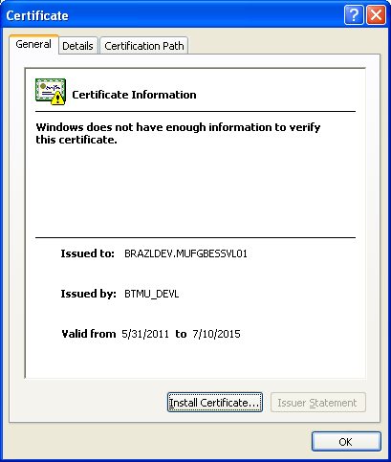

“Add” the CA certificate
On the Queue Manager Host, add the public certificate of the CA to the key repository of the queue manager. NOTE: This establishes trust for certificates received from other Queue Managers which have certificates signed by our CA. If the queue manager is communicating with Queue Managers with their own self-signed certificates (or third party certificates) the public key of their certificate or their CA must be added to the Queue Manager key repository to establish trust.

Windows
C:\...> runmqckm -cert -add -db key_file -pw password -type cms –file CAcertfile.cer -label "label"

UNIX
$gsk7capicmd -cert -add -db key_file -pw password -type cms -file CAcertfile.cer -label "label"

Development
key_file key.kdb
password PaTaGonia2010
days 1500
label "BTMUDevCACertificate"
CAcertfile.cer "BTMUdevCAcertfile.cer"

Production
key_file key.kdb
password YoSeMite1842
days 750
label “BTMUProdCACertificate"
CAcertfile.cer "BTMUprodCAcertfile.cer"

Examples
- From /var/mqm/qmgrs directory (in this example multiple queue managers are done from one directory by specifying path information):
gsk7capicmd -cert -add -db MQSIUAT3/ssl/key.kdb -pw PaTaGonia2010 -type cms -file MQSIUAT3/ssl/BTMUdevCAcertfile.cer -label BTMUDevCACertificate

gsk7capicmd -cert -add -db MQSIUAT3/ssl/key.kdb -pw PaTaGonia2010 -type cms -file MQSIUAT3/ssl/BTMUdevCAcertfileApr2022.cer -label BTMUDevCACertificateApr2022

- From /var/mqm/qmgrs/QMGRNAME/ssl
gsk7capicmd -cert -add -db key.kdb -pw PaTaGonia2010 -type cms -file BTMUdevCAcertfile.cer -label BTMUDevCACertificate

gsk7capicmd -cert -add -db key.kdb -pw PaTaGonia2010 -type cms -file BTMUdevPOCCAcertfile.cer -label BTMUDevPOCCACertificate

gsk7capicmd -cert -add -db key.kdb -pw YoSeMite1842 -type cms -file BTMUprodCAcertfile.cer -label BTMUProdCACertificate

- From D:\Program Files\IBM\WebSphere MQ\Qmgrs\IDTSIT4\ssl
runmqckm -cert -add -db key.kdb -pw PaTaGonia2010 -type cms -file BTMUdevCAcertfile.cer -label BTMUDevCACertificate
runmqckm -cert -add -db key.kdb -pw PaTaGonia2010 -type cms -file BTMUdevCAcertfileApr2022.cer -label BTMUDevCACertificateApr2022

- Public portion from Mercury (Tokyo)
gsk7capicmd -cert -add -db key.kdb -pw PaTaGonia2010 -type cms -file ibmwebspheremqqm.mic104_prepro_0711.txt -label ibmwebspheremqqm.mic104_prepro

gsk7capicmd -cert -add -db key.kdb -pw YoSeMite1842 -type cms -file ibmwebspheremqqm.mic104_2031.txt -label ibmwebspheremqqm.mic104_2031

- Public portion from BESSWireroom (Tokyo)
gsk7capicmd -cert -add -db key.kdb -pw PaTaGonia2010 -type cms -file BESSWireRoom.cer -label BESSWireRoom_CA

gsk7capicmd -cert -add -db key.kdb -pw PaTaGonia2010 -type cms -file BESSWireRoomLiveD3.cer -label BESSWireRoom_LiveD3_CA

gsk8capicmd -cert -add -db key.kdb -pw PaTaGonia2010 -type cms -file BESS-TANDEM-LIVE-Feb2035.cer -label BESSWireRoom_Live2035_CA

- Public portion from FRB
gsk7capicmd -cert -add -db key.kdb -pw PaTaGonia2010 -type cms -file FedCACert2027.cer -label FRB_CA_2027

gsk7capicmd -cert -add -db key.kdb -pw YoSeMite1842 -type cms -file FedCACert2027.cer -label FRB_CA_2027

Notes:
-  If –pw is not specified, this command will prompt you for a password. Supply the queue manager key repository’s password. This was chosen and first used in Step 3.2.
-  In order to use a certificate signed by the CA, and to trust other certificates signed by that CA, the key repository of the queue manager must contain the public certificate of the CA.
-  The label we used for the CA certificate, can different from the label it had in the CA’s own key repository. It is not necessary to do this, but it is possible.
-  Take note of the terminology used here. We have just added the public certificate of the CA to the key repository of the queue manager. This is a different action from receiving a certificate.

“Receive” the signed certificate
On the Queue Manager host, receive the certificate (now signed by the CA) into the queue manager’s key repository:

Windows
C:\...> runmqckm -cert -receive -db key_file -pw password -type cms
-file signed_file

UNIX
$gsk7capicmd -cert -receive -db key_file -pw password -type cms
-file signed_file

Where key_file key.kdb
password Dev: PaTaGonia2010
Prod: YoSeMite1842
signed_file qmgrname.cer
qmgrname name of the Queue Manager associated with this certificate

Examples
- From /var/mqm/qmgrs/MQSSIT1/ssl
gsk7capicmd -cert -receive -db key.kdb -pw PaTaGonia2010 -type cms -file mqsist1.cer

- From /var/mqm/qmgrs directory (in this example multiple queue managers are done from one directory by specifying path information):
gsk7capicmd -cert -receive -db MQSIUAT3/ssl/key.kdb -pw PaTaGonia2010 -type cms -file MQSIUAT3/ssl/mqsiuat3.cer

- From D:\Program Files\IBM\WebSphere MQ\Qmgrs\IDTUAT2\ssl
runmqckm -cert -receive -db key.kdb -pw PaTaGonia2010 -type cms -file idtuat2.cer

Notes:
- If –pw is not specified, this command will prompt you for a password. Supply the queue manager key repository’s password. This was chosen and first used in Step 3.2.
- The signed certificate must be received back into the same key repository that was used to create the certificate request.
- This key repository is the only place where the private key exists. The private key is uniquely partnered with the signed certificate.

The Internal Certificate Authority

Creating a certification authority (CA)
These steps describe how to create a CA using the command-line utilities supplied with WebSphere MQ.

Create a key repository for the CA
UNIX is the host platform for the CA. Host sfmqsidevl2 for development and mqsiprod for production. Create a directory, and in that directory create a key repository file, by entering the text shown below:

$gsk7capicmd -keydb -create -db filename -pw password -type cms
–stash -fips –strong

Development
filename BTMUdevCA.kdb
password Green35Eggs72Ham

Production
filename BTMUprodCA.kdb
password Civil1861War1865

Example:
mkdir MQ_DEV
cd MQ_DEV
gsk7capicmd -keydb -create -db BTMUdevCA.kdb -pw Green35Eggs72Ham -type cms -stash -fips -strong

mkdir MQ_PROD
cd MQ_PROD

gsk7capicmd -keydb -create -db BTMUprodCA.kdb -pw Civil1861War1865 -type cms -stash -fips -strong

mkdir MQ_AMS
cd MQ_AMS
gsk7capicmd -keydb -create -db BTMUAMSdevCA.kdb -pw Green35Eggs72Ham -type cms -stash -fips -strong

Notes:
- This GSKit key repository is needed to create and store the self-signed CA certificate, along with an associated private key.
- Keep the key repository password safe, as it protects the private key for your self-signed CA certificate. The password is required for all commands in this section.
- Three files are created by this command, in the current working directory. These are called BTMUdevCA.kdb, BTMUdevCA.crl and BTMUdevCA.rdb.
- All commands that specify -db BTMUdevCA.kdb later in this document will be issued from this directory.
- If you do not include the –pw specification, you will be prompted to create a password. Wait for the prompt, and then type the password you want to use for the CA’s key repository.
- The –strong flag will verify the strength of the password and reject the request if the password is weak.
- If you require the KeyDB password to expire add to the command: -expire days

Create your self-signed CA certificate
Create a self-signed CA certificate, which will be used to identify the Certificate Authority:

$gsk7capicmd -cert -create -db filename -pw password -label label
-dn distinguished_name -size key_size -x509version version
-expire days -fips -ca true
-sigalg md5 | sha1 | sha224 | sha256 | sha384 | sha512

The following uses defaults

$gsk7capicmd -cert -create -db filename -pw password -label label
-dn distinguished_name -size key_size expire days
-fips -ca true

Development
filename BTMUdevCA.kdb
label BTMUDevCACertificate
password Green35Eggs72Ham
days 3650
key_size 1024
distinguished_name "CN=BTMU_DEVL,O=BTMU,OU=ITS.SOA.MQ,L=NewJersey,C=US"

Production
filename BTMUprodCA.kdb
label BTMUProdCACertificate
password Civil1861War1865
days 3650
key_size 1024
distinguished_name "CN=BTMU_PROD,O=BTMU,OU=ITS.SOA.MQ,L=NewJersey,C=US"

Example:
gsk7capicmd -cert -create -db BTMUdevCA.kdb -pw Green35Eggs72Ham -label BTMUDevCACertificate -dn "CN=BTMU_DEVL,O=BTMU,OU=ITS.SOA.MQ,L=NewJersey,C=US" -size 1024 -expire 3650 -fips

gsk7capicmd -cert -create -db BTMUprodCA.kdb -pw Civil1861War1865 -label BTMUProdCACertificate -dn "CN=BTMU_PROD,O=BTMU,OU=ITS.SOA.MQ,L=NewJersey,C=US" -size 1024 -expire 3650 -fips

gsk7capicmd -cert -create -db BTMUAMSdevCA.kdb -pw Green35Eggs72Ham -label BTMUAMSDevCACertificate -dn "CN=BTMU_AMS_DEVL,O=BTMU,OU=ITS.SOA.MQ,L=NewJersey,C=US" -size 1024 -expire 3650 -fips

<<CREATE a NEW CA Certificate for PROD>>
A New Certificate was created with the X.508 CA Extension for JMS client support
[
gsk7capicmd -cert -create -db BTMUprodCAapr2022.kdb -pw xxxxxxx -label BTMUProdCACertificateApr2022 -dn "CN=BTMU_PROD_Apr2022,O=BTMU,OU=ITS.SOA.MQ,L=NewJersey,C=US" -size 1024 -expire 3650 -ca true -fips

Notes:
- The CA certificate is created inside the key repository. It is not yet extracted into a file – we will do this in Step 2.3.
- The -expiry parameter specifies the number of days, from the current date, until the CA certificate expires. This also limits the maximum expiry date of any certificate signed using the CA certificate.
- The distinguished name (DN), as specified in the -dn parameter, should be tailored to your organization, and usage of the CA.
- Information about the components that make up the distinguished name is provided in the WebSphere MQ Security manual.

Extract the CA certificate
Extract the CA public certificate into a file called BTMUdevCAcertfile.cer, which we will later transfer to the key repositories of the queue manager and client applications.:

$gsk7capicmd -cert -extract -db filename -pw password -label label
-target targetname -format ascii –fips

Development
filename BTMUdevCA.kdb
password Green35Eggs72Ham
label BTMUDevCACertificate
targetname BTMUdevCAcertfile.cer

Production
filename BTMUprodCA.kdb
password Civil1861War1865
label BTMUProdCACertificate
targetname BTMUprodCAcertfile.cer

Example:
gsk7capicmd -cert -extract -db BTMUdevCA.kdb -pw Green35Eggs72Ham -label BTMUDevCACertificate -target BTMUdevCAcertfile.cer -format ascii –fips

gsk7capicmd -cert -extract -db BTMUprodCA.kdb -pw Civil1861War1865 -label BTMUProdCACertificate -target BTMUprodCAcertfile.cer -format ascii -fips

gsk7capicmd -cert -extract -db BTMUAMSdevCA.kdb -pw Green35Eggs72Ham -label BTMUAMSDevCACertificate -target BTMUAMSdevCAcertfile.cer -format ascii -fips

Notes:
- In this Step, we have extracted only the public certificate of the CA. The private key associated with this certificate is held securely in the key repository.
- In later Steps, we show how the CA certificate is added into the key repositories of other entities in the infrastructure.
- The CA certificate is added into the key repositories of other entities, in order to make those entities trust the certificates signed by the CA.

Signing Certificate Requests

Receive the CSR
The certificate request file contains Base64 encoded ASCII data. If you plan to use FTP to transfer this file between machines, then you should use the “ascii” command in the FTP client program before the “put” or “get” commands to ensure the file is transferred in the correct format.

Optionally as the certificate requests are text files looking like the following, they can be emailed as either attachments, or in the body of the email.

-----BEGIN NEW CERTIFICATE REQUEST-----
MIIBZzCB0QIBADAoMSYwJAYDVQQDDB1UMlFNR1Igb3U9QlRNVSBvPVNPQS1JVFMg
Yz1VUzCBnzANBgkqhkiG9w0BAQEFAAOBjQAwgYkCgYEA69dsGb7yP7xnh7MHmidD
h2gu3gYO46eVreoIQuv4nUfiuwM30DXfoOHsvI03QwoZ+xFqssPmdjDJhVsaQgSp
oLaYxln4x1ck5MG2nzxaBAmjkzxwahHydPVvsKoBcteOXKPMMuZo/T935pcWmBF3
Um3Ut09jckBYD8hQPwwxiVECAwEAAaAAMA0GCSqGSIb3DQEBBQUAA4GBAGsmiIpB
7NbfrJZuC8c8ERg9t9Df7xcaHK6HPw2VbCekL+8s7vS9CSc4HQmxU1Kui1WBNkBR
LEUxFflUvBxmVyX1oBI2B8n2y1oO7+FvGLhoWAPNUmCpuJeNXReHk69AOpcwf0fI
yzDorNnqtKFhjTvsNEU08EPfPBp11NBNS07n
-----END NEW CERTIFICATE REQUEST-----

Sign the queue manager’s certificate
Logon to the host running the Certificate Authority (sfmqsidevl2 for development or mqsiprod for production) and run the following command to sign the Queue Manager’s certificates:

$gsk7capicmd -cert -sign -db key_file -pw password -label "label"
-expire days -format ascii -file request_file -target signed_file

Development
key_file BTMUdevCA.kdb
password Green35Eggs72Ham
days 1500
label "BTMUDevCACertificate"
request_file qmgrname.req
signed_file qmgrname.cer
qmgrname name of the Queue Manager associated with this key

Production
key_file BTMUprodCA.kdb
password Civil1861War1865
days 750
label "BTMUProdCACertificate"
request_file qmgrname.req
signed_file qmgrname.cer
qmgrname name of the Queue Manager associated with this key

Example

gsk7capicmd -cert -sign -db BTMUdevCA.kdb -pw Green35Eggs72Ham -label "BTMUDevCACertificate" -expire 1500 -format ascii -file idtuat2.req -target idtuat2.cer

gsk7capicmd -cert -sign -db BTMUprodCA.kdb -pw Civil1861War1865 -label "BTMUProdCACertificate" -expire 750 -format ascii -file mqcmprd1.req -target mqcmprd1.cer

Notes:
- This command will prompt you for a password. Supply the CA key repository’s password. This was chosen and first used in Step 1.1.
- The -expiry parameter specifies the number of days, from the current date, until the signed certificate expires. The date of expiry cannot be later than the date of expiry of the CA certificate.

Transfer the CA-signed certificate
Two files should be transferred back to the entity (whether a queue manager, or an application):

- The CA certificate.
- The signed .cer certificate file.

Both of these X.509 certificates contain Base64 encoded ASCII data. The same mechanism (ftp or email) can be used to transfer the certificate back to the entity, as was used to transfer the certificate request from the entity to the CA. The certificates will look like the following:
-----BEGIN CERTIFICATE-----
MIIB/TCCAWagAwIBAgIIhwtbZMhMiFEwDQYJKoZIhvcNAQEFBQAwWjEMMAoGA1UE
BgwDVVNBMRIwEAYDVQQHDAlOZXdKZXJzZXkxDTALBgNVBAoMBEJUTVUxEzARBgNV
BAsMCklUU19TT0FfTVExEjAQBgNVBAMMCUJUTVVfREVWTDAeFw0xMTEyMTkxNzA4
NDVaFw0xMjAyMDMxNzA4NDVaMCgxJjAkBgNVBAMMHVQyUU1HUiBvdT1CVE1VIG89
U09BLUlUUyBjPVVTMIGfMA0GCSqGSIb3DQEBAQUAA4GNADCBiQKBgQDr12wZvvI/
vGeHsweaJ0OHaC7eBg7jp5Wt6ghC6/idR+K7AzfQNd+g4ey8jTdDChn7EWqyw+Z2
MMmFWxpCBKmgtpjGWfjHVyTkwbafPFoECaOTPHBqEfJ09W+wqgFy145co8wy5mj9
P3fmlxaYEXdSbdS3T2NyQFgPyFA/DDGJUQIDAQABMA0GCSqGSIb3DQEBBQUAA4GB
AIHNCVX7aXW6kSdnN0m8Ke+JdvucJK1yTccITA7rGL7tx0dkxOn3rL6EdyJ6QDnh
0iAm2KLRGjIrs+6Y1+g8/Vx7J0qqES1FKuF2L6zTKP7Xb0VGs4UZislto5eTK/ht
PA6iRvJoqipsbY6hQl9t6lO2Qy/LkiZNycGYzyFwEgJ3
-----END CERTIFICATE-----

Using self-signed certificates for mutual authentication on UNIX® systems or Windows

Create KDB
Prepare the key repository on each queue manager, as described in “Setting up a key repository” on UNIX and Windows systems. Example:
Cd C:\Program Files\IBM\WebSphere MQ\Qmgrs\CBMQ2\ssl
runmqckm -keydb -create -db key.kdb -type cms –stash
PW=gobabygo

Create Self signed Cert
Create a self-signed certificate for each queue manager, as described in Creating a self-signed personal certificate on UNIX or Windows systems. Example
runmqckm -cert -create -db key.kdb -pw gobabygo -label ibmwebspheremqcbmq1 -dn "CN=CBMQ1" -size 1024 -expire 365
runmqckm -cert -create -db key.kdb -pw gobabygo -label ibmwebspheremqcbmq2 -dn "CN=CBMQ2" -size 1024 -expire 365

Extract public part of cert
Extract a copy of each certificate, as described in “Extracting the public part of a self-signed certificate” from a key repository on UNIX systems and Windows. In order to authenticate a partner's certificate when using self-signed certificates, you must send a copy to the partner system. In order to send it, you must first extract it. Example
runmqckm -cert -extract -db key.kdb -pw gobabygo -label ibmwebspheremqcbmq1 -target cbmq1.arm -format ascii

runmqckm -cert -extract -db key.kdb -pw gobabygo -label ibmwebspheremqcbmq2 -target cbmq2.arm -format ascii

Transfer Certificates
Optional: If QM1 and QM2 are running on different systems, transfer the public part of the QM1 certificate to the QM2 system and vice versa, as described in “Exchanging self-signed certificates”. Example
cd CBMQ2\ssl
copy cbmq2.arm ..\..\CBMQ1\ssl
cd CBMQ1\ssl
copy cbmq1.arm ..\..\CBMQ2\ssl

Add the public part of a self-signed certificate) into a key repository, on UNIX systems or Windows
Add the partner's certificate to the key repository as a signer certificate, as described in “Adding a CA certificate” (or the public part of a self-signed certificate) into a key repository, on UNIX systems or Windows.
cd CBMQ2\ssl
runmqckm -cert -add -db key.kdb -pw gobabygo -label ibmwebspheremqcbmq1 -file cbmq1.arm -format ascii

cd CBMQ1\ssl
runmqckm -cert -add -db key.kdb -pw gobabygo -label ibmwebspheremqcbmq2 -file cbmq2.arm -format ascii

Setup MQ
- On QM1, define a sender channel and transmission queue, as described in Defining a sender channel and transmission queue on QM1.
- On QM2, define a receiver channel, as described in Defining a receiver channel on QM2.
- Start the channel, as described in Starting the sender channel.

Back up your SSL certificate
Personal certificates that are signed by external CAs (like the FED certificate) and its corresponding private key, must be backed up to another server in the event that there is a hardware failure or other disaster affecting the primary server, the following instructions will show you how. These instructions will also help you export your certificate from Queue Manager and import the certificate and its private key to another Queue Manager.

Export Key to a PKCS12

To export a personal certificate using gsk7ikm GUI:
- Set Environment Variables for Exceed
who
u002385 pts/0 Dec 15 08:12 (us-njc-lkfxkx6.ad.btmna.com)
export DISPLAY=us-njc-lkfxkx6:0
export PATH=$PATH:/usr/bin:/bin
export JAVA_HOME=/usr/mqm/ssl/jre

- Start Exceed on your Desktop and set Environment Variables
- Enter gsk7ikm on a command line on Unix.
- Select Key Database File from the main UI and then select Open.
- In the Open dialog box, enter your key database name or click on key.kdb if you are using the default. Click OK.
- In the Password Prompt dialog box, enter your correct password and click OK.
- Select Personal Certificates in the Key Database content frame and then click the Export/Import button on the label.
- In the Export/Import Key window:
  - Select Export Key.
  - Select the PKCS12 database file type.
  - Enter the file name or use the Browse option.
  - Enter the correct location.
- Click OK.
- In the Password Prompt dialog box, enter the correct password, enter the password again to confirm and then click OK to export the selected key to a PKCS12 file.

To export a personal certificate using GSK7Cmd
On UNIX:
gsk7cmd -cert -export -db myqmgr.kdb -pw password -type cms
-label label -target tgtfilename -target_pw tgtpassword
-target_type pkcs12
On Windows:
runmqckm -cert -export -db myqmgr.kdb -pw password -type cms
-label label -target tgtfilename -target_pw tgtpassword
-target_type pkcs12

Where myqmgr.kdb key.kdb
password Devel: PaTaGonia2010
Prod: YoSeMite1842
label the label attached to the certificate. Format:
ibmwebspheremqqmgrname
tgtfilename the name of the destination file.pkcs12 tgtpassword the password for encrypting the certificate in
the target file

Example:
gsk7cmd -cert -export -db key.kdb -pw PaTaGonia2010 -type cms -label ibmwebspheremqfedgwu01 -target fedgwu01_backup.p12 -target_pw BaCkUp2011 -target_type pkcs12

gsk7cmd -cert -export -db key.kdb -pw YoSeMite1842 -type cms -label ibmwebspheremqfedgwp01 -target fedgwp01_backup.p12 -target_pw BaCkUp2011 -target_type pkcs12

Notes:
-  If you do not include the –pw or –tgtpassword specification, you will be prompted to create a password. Wait for the prompt, and then type the password you want to use for the CA’s key repository.
- It is important that this password is kept safe, as it protects the private key of the signed certificate. The tgtpassword is required to restore (Import) the certificate.
- Save the exported pkcs12 file to another server as it will be required if the server needs to be rebuilt!

Import Key from a PKCS12

To import a personal certificate using gsk7ikm GUI:
- Set Environment Variables for Exceed
$who
u002385 pts/0 Dec 15 08:12 (us-njc-lkfxkx6.ad.btmna.com)
$ export DISPLAY=us-njc-lkfxkx6:0
$ export PATH=$PATH:/usr/bin:/bin
$ export JAVA_HOME=/usr/mqm/ssl/jre

- Start Exceed on your Desktop and set Environment Variables
- Enter gsk7ikm on a command line on Unix..
- Select Key Database File from the main UI and then select Open.
- In the Open dialog box, enter your key database name or click on key.kdb if you are using the default. Click OK.
- In the Password Prompt dialog box, enter your correct password and click OK.
- Select Personal Certificates in the Key Database content frame and then click the Export/Import button on the label.
- In the Export/Import Key window:
  - Select Import Key.
  - Select PKCS12.
  - Enter the file name or use the Browse option.
  - Select the correct location.
- Click OK.
- In the Password Prompt dialog box, enter the correct password and then click OK.

To import a personal certificate using GSK7Cmd

On UNIX:
gsk7cmd -cert -import -file certfilename -pw cfpassword -type pkcs12
-label label -target myqmgr.kdb -target_pw kcbpassword
-target_type cms

On Windows:
runmqckm -cert -import -file filename -pw password -type pkcs12
-target filename -target_pw password -label label
-target_type cms

Where certfilename the name of the pkcs12 file containing the backup certificate
cfpassword the password for decrypting the certificate in
the backup file (BaCkUp2010)
myqmgr.kdb key.kdb
kdbpassword Devel: PaTaGonia2010
Prod: YoSeMite1842
label the label attached to the certificate. Format:
ibmwebspheremqqmgrname

Example:
gsk7cmd -cert -import -file fedgwu01_backup2.p12 -pw BaCkUp2011 -type pkcs12 -label ibmwebspheremqfedgwu01 -label FRB_CA_2027 -target key.kdb -target_pw PaTaGonia2010 -target_type cms
runmqckm -cert -import -file qpprod_backup.p12 -pw BaCkUp2011 -type pkcs12 -label ibmwebspheremqqpprod -target key.kdb -target_pw YoSeMite1842 -target_type cms

Notes:
-  If you do not include the –pw or –tgtpassword specification, you will be prompted to create a password. Wait for the prompt, and then type the password you want to use for the CA’s key repository.
- When using the CLI, the signer (CA) certificate must exist in the key database before the personal certificate can be imported. It can be added per the normal procedure, or it can be imported by specifying its label. When the GUI is used, the signer certificate is imported along with the personal certificate.

Change Label
The label of the MQ Certificate can be changed by exporting the key store, and then importing the certificate with a new label.
We are currently using this technique so we can use the same certificate on FEDGWP01 and FEDGWP02 for FED DR tests.
- Export the certificate from FEDGWP01
gsk7cmd -cert -export -db key.kdb -pw YoSeMite1842 -type cms -label ibmwebspheremqfedgwp01 -target fedgwp01_backup.p12 -target_pw BaCkUp2011 -target_type pkcs12

- Create the key.kdb, and add all the appropriate CA certificates
- Copy the certificate to FEDGWP02/ssl
- Import the certificate specifyin the new_label parameter.

gsk7cmd -cert -import -file fedgwp01_backup.p12 -pw BaCkUp2011 -type pkcs12 -target key.kdb -target_pw PaTaGonia2010 -target_type cms -label ibmwebspheremqfedgwp01 -new_label ibmwebspheremqfedgwp02

Notes:
-  If you do not include the –pw or –tgtpassword specification, you will be prompted to create a password. Wait for the prompt, and then type the password you want to use for the CA’s key repository.
- When using the CLI, the signer (CA) certificate must exist in the key database before the personal certificate can be imported. It can be added per the normal procedure, or it can be imported by specifying its label. When the GUI is used, the signer certificate is imported along with the personal certificate.

OTHER

PROBLEM: Duplicate certificate serial numbers
Platform: All
Problem description
You encounter errors when processing certificates that have been signed using GSkit because more than one certificate has the same serial number.
This can occur, for instance, if you generate more than one certificate request using RACF (z/OS) and then sign them using GSKit (i.e. using the gsk7cmd command on Windows or Unix). By default GSKit can give multiple certificates the same serial number, meaning that only one of the signed certificates will be accepted by RACF – which validly treats all the signed certificates with the same serial number as the same certificate.
Solution
GSKit was never intended as a PKI substitute so you should manage serial numbers manually for the certificates you sign or alternatively sign your certificates using another SSL signing system (e.g. OpenSSL or RACF).
To manually set serial numbers use the ‘–sernum’ runmqckm option, as follows :
runmqckm -cert -sign -file <certreq file> -db <db file> -pw <password> -label <label> -target <cert file> -format ASCII -expire <expire days> -sernum <serial number>
Having to manually set serial numbers implies that you need a serial number authority (most likely the certificate authority itself) which uses a number naming convention.

Renewing WebSphere MQ SSL Certificates
Problem description
You want to know whether the Renewal of existing SSL certificates is possible when using IBM Key Management or Digital Certificate Management.
Solution
WebSphere MQ has the following certificate label restrictions and you must follow the naming convention 'ibmwebspheremqXXXXX', it is not possible to renew an existing certificate within the same database. (where xxxxx is the queue manager name)

Please use the steps below for the appropriate platform in order to circumvent this problem.

On UNIX and Windows
It is recommended that the user renews certificates in the database in the following way:
.
- Create copies of all the 'key.*' files (key.kdb, key.sth, key.crl,key.rdb) into another directory. The original files are left untouched in the original location, so, while the update process is performed, WebSphere MQ is able to continue using the old certificates, uninterrupted.

- In the IBM Key Management, open the backed up key database stored in the directory specified in the previous step.

- In the copy of the key database, delete the personal certificate from the "Personal Certificates" view.

- Create a new certificate with the name 'ibmwebspheremqXXXXX' in the "Personal Certificate Requests". Send the *.arm file to the Certificate Authority.

- Receive the signed certificate request into the copy of the key database (to create a complete certificate).

- Stop the WebSphere MQ queue manager.

- Copy the 'copy' of the key database back over the original key database (replace the original key database with the newly updated key database).

NOTE: It is recommended that the user makes another backup of the original key database before copying over it, in case there is a need to 'roll back' to the original key database/certificate.

- Restart the WebSphere MQ queue manager and confirm that the channels start successfully.

Using Exceed and gsk7ikm on UNIX
Get your terminal name and set DISPLAY variable to the terminal name:
$who
u002385 pts/0 Dec 15 08:12 (us-njc-lkfxkx6.ad.btmna.com)
$export DISPLAY=us-njc-lkfxkx6:0
Set PATH to include /usr/bin and /bin
$export PATH=$PATH:/usr/bin:/bin
Set JAVA_HOME
$export JAVA_HOME=/usr/mqm/ssl/jre
Start Exceed on terminal in DISPLAY
Run GSK
$gsk7ikm
Dec 15, 2010 8:36:51 AM java.util.prefs.FileSystemPreferences$2 run
INFO: Created user preferences directory.
Key Management window opens in Exceed on terminal
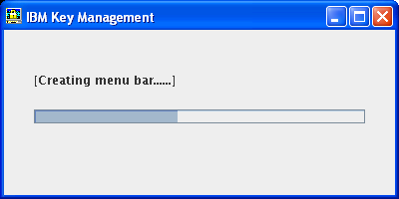

Open Key store
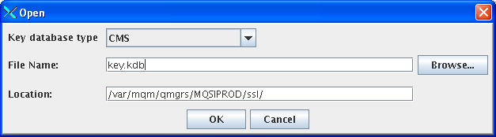
Enter passphrase for keystore
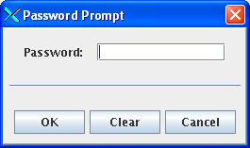

Perform GSK functions.
Display Personal certificates.
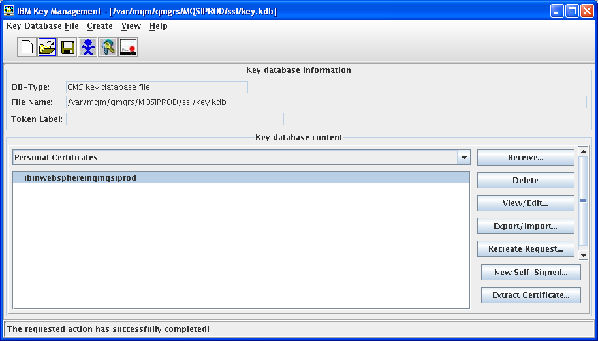
Display Signer Certificates
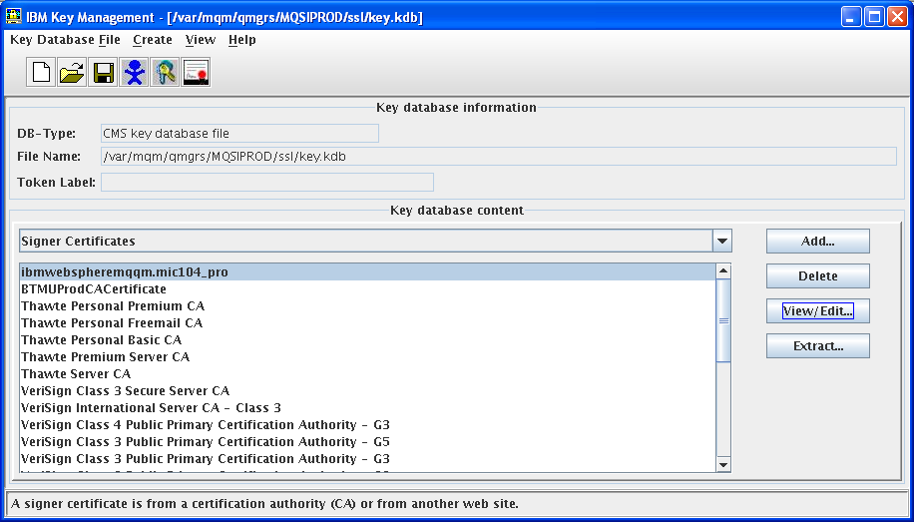
Display Certificate Details (including expiration)
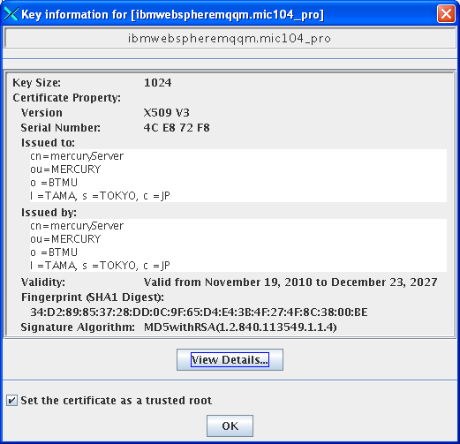
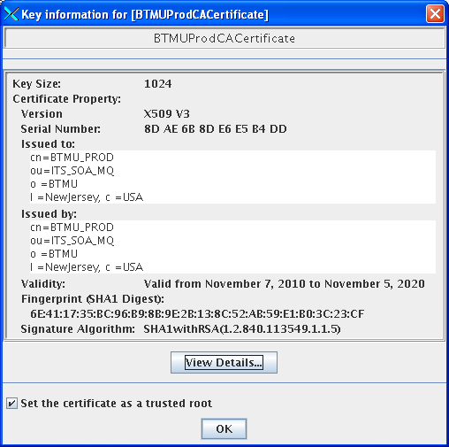

Commands

Delete Certs
runmqckm -cert -delete -db key.kdb -label BTMUDevCACertificate

gsk7capicmd -cert -delete -db key.kdb -pw PaTaGonia2010 -label ibmwebspheremqintgwd03

gsk7capicmd -cert -delete -db key.kdb -pw PaTaGonia2010 -label ibmwebspheremqqm.mic104_prepro

gsk7capicmd -cert -delete -db key.kdb -pw YoSeMite1842 -label ibmwebspheremqfedgwp01

gsk7capicmd -cert -delete -db key.kdb -pw PaTaGonia2010 -label BESSWireRoom_D3_CA

List Certs
gsk8capicmd -cert -list -db key.kdb -pw PaTaGonia2010

gsk7capicmd -cert -list -db BTMUdevCA.kdb -pw Green35Eggs72Ham

gsk8capicmd -cert -list -db key.kdb -pw YoSeMite1842

runmqckm -cert -list -db key.kdb -pw YoSeMite1842

gsk8capicmd -cert -details -showOID -db key.kdb -pw PaTaGonia2010 -label ibmwebspheremqqm.mic104_prepro_2031

gsk7capicmd -cert -details -db key.kdb -pw PaTaGonia2010 -label ibmwebspheremqintgws01

gsk7capicmd -cert -details -db key.kdb -pw YoSeMite1842 -label ibmwebspheremqmqsiprod

runmqckm -cert -details -showOID -db key.kdb -pw GoBabyGo -label Charles

List Expiration
gsk7capicmd -keydb -expiry -db key.kdb -pw PaTaGonia2010

runmqckm -keydb -expiry -db key.kdb -pw PaTaGonia2010

Change KeyDB Password (with no expiry)
gsk7capicmd -keydb -changepw -db key.kdb -pw PaTaGonia2010 -new_pw PaTaGonia2012 –stash

Remove KeyDB Expiry
runmqckm -keydb -changepw -db key.kdb -pw PaTaGonia2010 -new_pw PaTaGonia2010 -stash

Change Label
gsk7cmd -cert -export -db key.kdb -pw PaTaGonia2010 -label ibmwebspheremqextgws02 -type cms -target extgws01_backup.p12 -target_pw Backup2012 -target_type pkcs12

gsk7cmd -cert -import -file extgws01_backup.p12 -pw Backup2012 -type pkcs12 -target key.kdb -target_pw PaTaGonia2010 -target_type cms -label ibmwebspheremqextgws02 -new_label ibmwebspheremqextgws01

gsk8capicmd -cert -import -db intgws02_backup_20140515.p12 -pw BaCkUp2014 -label ibmwebspheremqintgws02 -target key.kdb -target_pw PaTaGonia2010 -new_label ibmwebspheremqtestqm -target_type cms

SSL CipherSpec Check

openssl s_client -ssl3 -connect "10.85.82.73:1414"
openssl s_client -tls1 -connect "10.85.82.73:1414"

Brazil will be "CN=qmgrname.host,O=BTMU,OU=ITS_SOA_MQ, L=San Paulo,C=BR" - "CN=BRAZLDEV.MUFGBESSVL01,O=BTMU,OU=ITS.SOA.MQ,L=Sao Paulo,C=BR" - "CN=BRAZLUAT.MUFGBESSVL01,O=BTMU,OU=ITS.SOA.MQ,L=Sao Paulo,C=BR" - "CN=BRAZLPRD.MUFGBESS01,O=BTMU,OU=ITS.SOA.MQ,L=Sao Paulo,C=BR" Mexico will be "CN=qmgrname.host,O=BTMU,OU=ITS.SOA.MQ,L=Mexico,C=MX"

